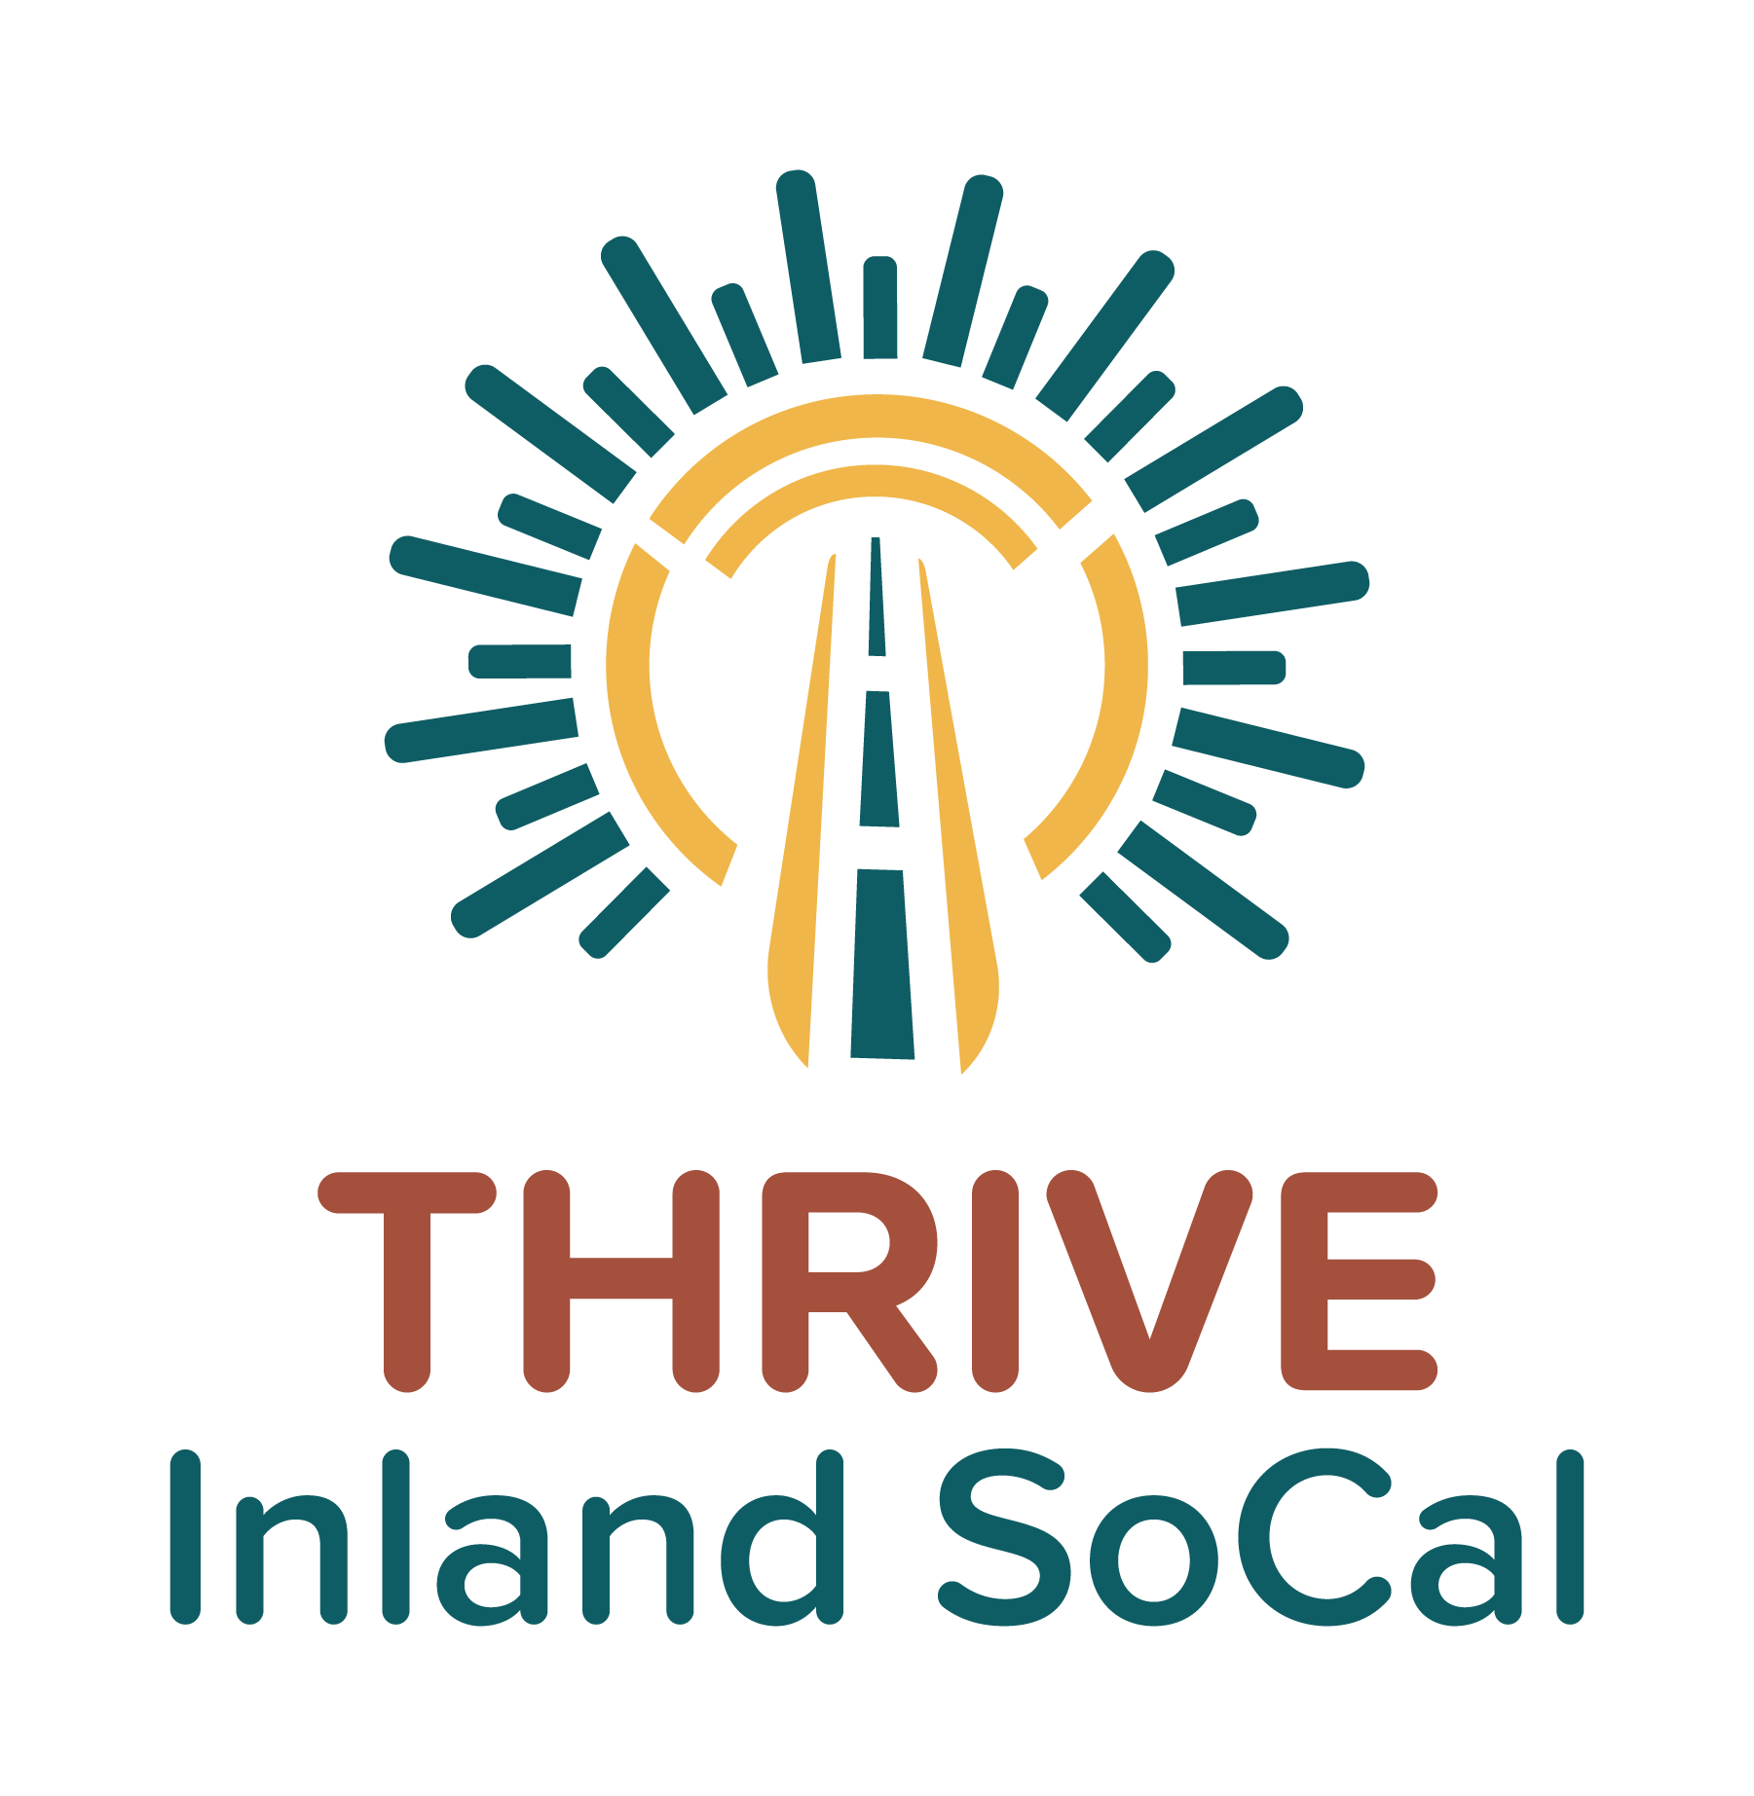

**Event Planning Toolkit**

Identifying Inland SoCal Sub-Regional Table Targets 1

Researching Events and Presentation Opportunities 1

Examples of Events 1

Event Coordination 2

Outreach Event Sample Email Template 2

Listening Session or Focus Group Email Template 2

Proof of Nonprofit Status for Reduced or Free Booth Space at Events 3

Certificate of Insurance (COI) 3

Outreach & Engagement Event Planning Notes 3

Event/Presentation Outreach Materials 3

Key Performance Indicators (KPI) to Track for Reporting Purposes 4

Lessons Learned 4

Event/Group Pictures 4

# Identifying Inland SoCal Sub-Regional Table Targets

* High Desert
* Coachella Valley/Morongo
* Greater San Bernardino
* Greater Riverside
* Southwest Riverside
* Western San Bernardino

## *Researching Events and Presentation Opportunities*

You can search events by using Google, Facebook events, Eventbrite, local newspapers, city event calendars, chamber of commerce calendars, local community-based organization (CBO) calendars/newsletters, etc.

## *Examples of Events*

These can include, but not be limited to:

* Community fairs
* Health/esource fairs
* Job fairs
* Heritage/culture celebrations
* Equity or environmental justice organization gatherings (networking)
* CBO and neighborhood council member meetings
* Faith-based organization events
* Community college and university events

**Note**: Bigger events do not necessarily equal big results. Smaller events often lead to higher quality of engagement.

## *Event Coordination*

After identifying an event, you will need to register to participate. Some events have registration forms, or you may need to send an email to the contact person.

In addition to tabling at an event, you might also decide to host your own listening session or focus group. Please see below for email templates for these two scenarios.

#### Outreach Event Sample Email Template

(Feel free to modify as needed)

Hello [Name or organization],

I hope this email finds you well. We are interested in attending the [Event] on [Date] and having a booth representing the Thrive Inland SoCal project. We are XXXXX.

Please let me know if additional information is needed for us to participate. I look forward to your response.

Thank you,

#### Listening Session or Focus Group Email Template

(Feel free to modify as needed; include/attach any flyer or additional information if available)

Hello [Name or organization],

I am XXXXX XXXXX and represent Thrive Inland SoCal, a collaborative funded by California Jobs First, formerly known as the Community Economic Resilience Fund (CERF). CERF was created by the California Legislature to promote a sustainable and equitable recovery from the economic distress from the COVID-19 pandemic by supporting new plans and strategies to diversify local economies and develop sustainable industries that create high-quality, broadly accessible jobs for all Californians.

We are currently gathering insights from organizations like yours and your members important to what an inclusive economic development plan should look like for your community. This information will be submitted to XXX for further funding consideration to assist with the economic growth of our Inland Empire communities. I am reaching out to gauge interest in opportunities for your community members to participate in conversations to better understand where they would like to see our region’s economy grow.

If this is of interest, please contact me. I also can provide more details on our efforts and explain our timeline for completing this community input phase.

Thank you for your time and consideration.

Thank you,

# Proof of Nonprofit Status for Reduced or Free Booth Space at Events

* For some outreach events, the booth fee will be lower or waived if you are a nonprofit organization.
* The event producer may request proof of your organization’s nonprofit status.You may want to send your IRS Ruling Tax Exempt letter as proof.

# Certificate of Insurance (COI)

* If insurance documentation is requested by the event organizer, get details about the insurance requirements.
* Check with your organization’s operations team to access this information for the COI.

# Outreach & Engagement Event Planning Notes

[The CSE team has created planning documents](https://drive.google.com/drive/folders/1SupLjxr7BI0TgA5bDv2DtFDNxA3VIBjj?usp=drive_link) to assist with tracking the information below and preparing for any meetings or events. This will help with tracking your outreach activities for logistics and reporting purposes:

* Event
* Date of event or presentation
* Point of contract for event or presentation
* Point of contact’s email and/or physical address of event or presentation
* Phone number for point of contact
* Any other pertinent information
* Number of attendees (entered after event or presentation)

# Event/Presentation Outreach Materials

Make sure you have all materials needed for your event or presentation, such as:

* Clipboards
* Pens
* Thrive flyers (both English and in-language)
* Giveaways
* Gift cards
* Email sign up sheet (if participant would like to track and/or receive additional information via a website or newsletter)
* Interpreter
* Interpretation equipment
* Survey equipment (e.g., tablets)
* Charging and extension cords
* For presentations/listening sessions, list and identify a team to assist with gathering important information

# Key Performance Indicators (KPI) to Track for Reporting Purposes

* Number of attendees
* Number of individual conversations
* Number of surveys collected
* Number of flyers distributed
* Any other pertinent information

# Lessons Learned

Document successes and areas for improvement in a brief paragraph or with bullet points. This information can help your team or others learn from your experiences and facilitate the exchange of knowledge.

# Event/Group Pictures*

After an event or presentation, please add any photos you took during the event and submit them with your regular activity report. Remember, a picture can help tell the story.

*You may need a photo release form if the pictures are to be used in a public setting or in printed or online material, such as flyers or social media posts.